# CS 255 System Design Document

Author: Magdiel Rosario

## UML Diagrams

### UML Use Case Diagram

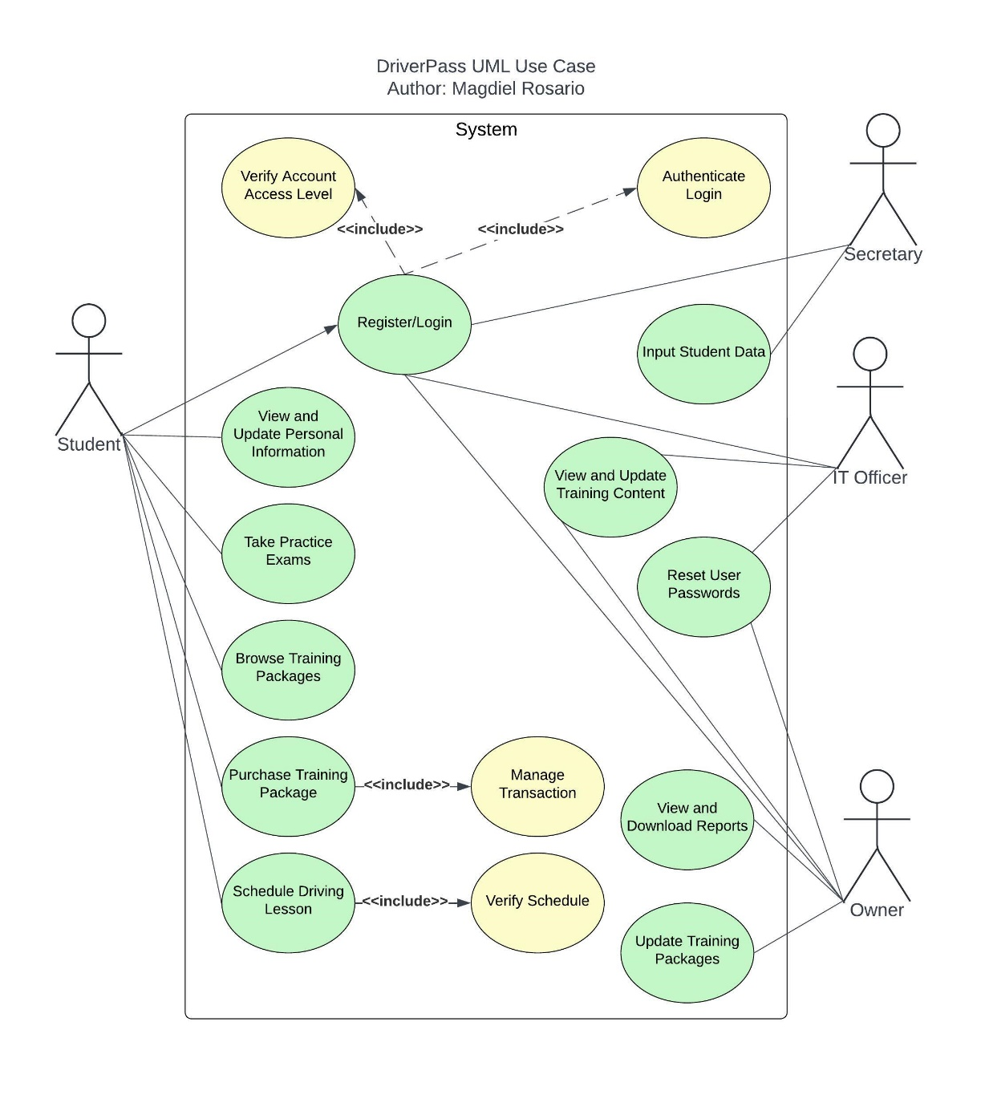

### UML Activity Diagrams

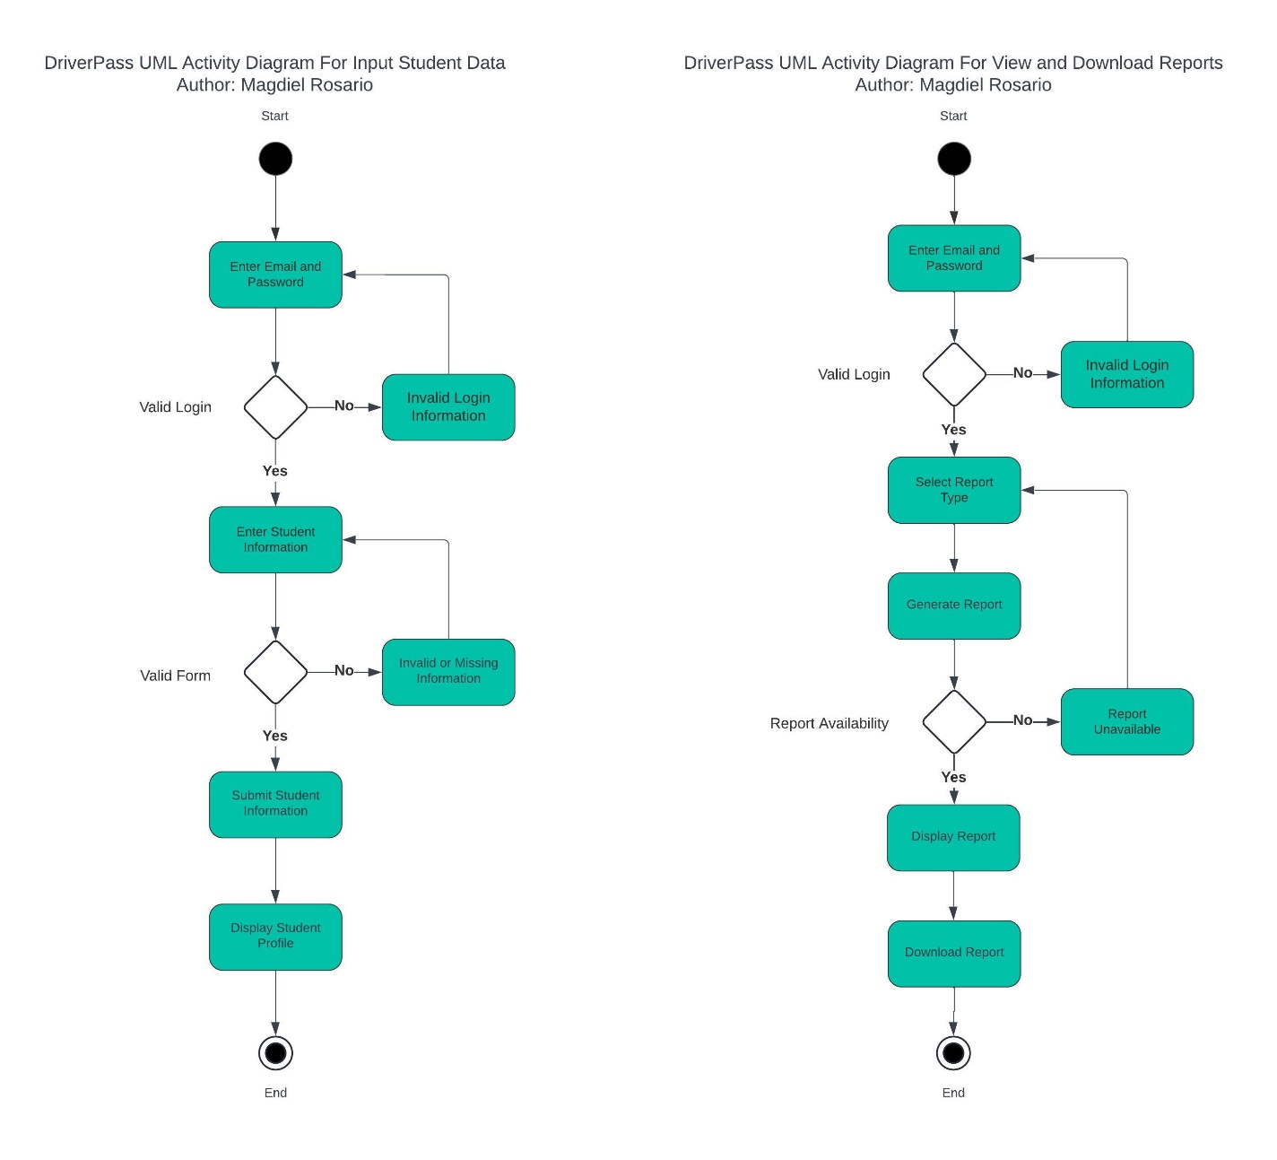

### UML Sequence Diagram

### UML Class Diagram

## Technical Requirements

**Hardware**

* *Server*
  + Cloud server
  + Multi-core processors
  + Minimum of 16 GB RAM
  + Minimum of 1 TB SSD
  + Redundant power supply
  + Peripherals
* *Client*
  + Desktop, Laptop, or Mobile Device
  + Reliable internet

**Software**

* *Server Operating System*
  + Ubuntu Server Distribution
  + Node.js or Java Runtime
* *Client Operating System*
  + Windows, MacOS, iOS, Android, or Linux
  + Web browser
* *Database Management System*
  + PostgreSQL

**Tools**

* *Integrated Development Environment*
  + Visual Studio Code, Eclipse, or similar programming IDE
* *Version Control*
  + Git with GitHub
* *Testing Tools*
  + JUnit for Java or similar
* *Security Tools*
  + Firewall Solutions
  + Data Encryption Protocols
  + Authentication such as OAuth or similar

**Infrastructure**

* Cloud services such as AWS or Google Cloud
* Automated backups
* Backup power supply
* Well-ventilated dedicated room
* High-speed internet provider
* At least one IT Officer
* Any storage device containing sensitive information must be in a locked cabinet